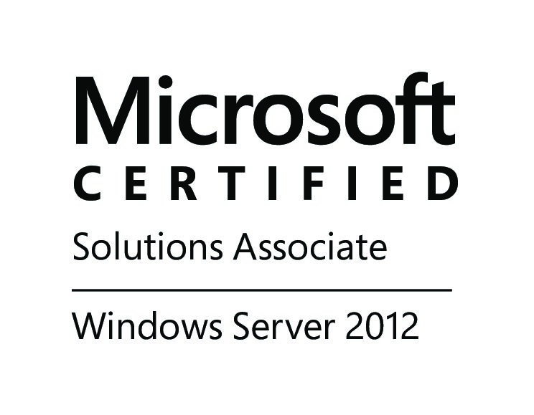
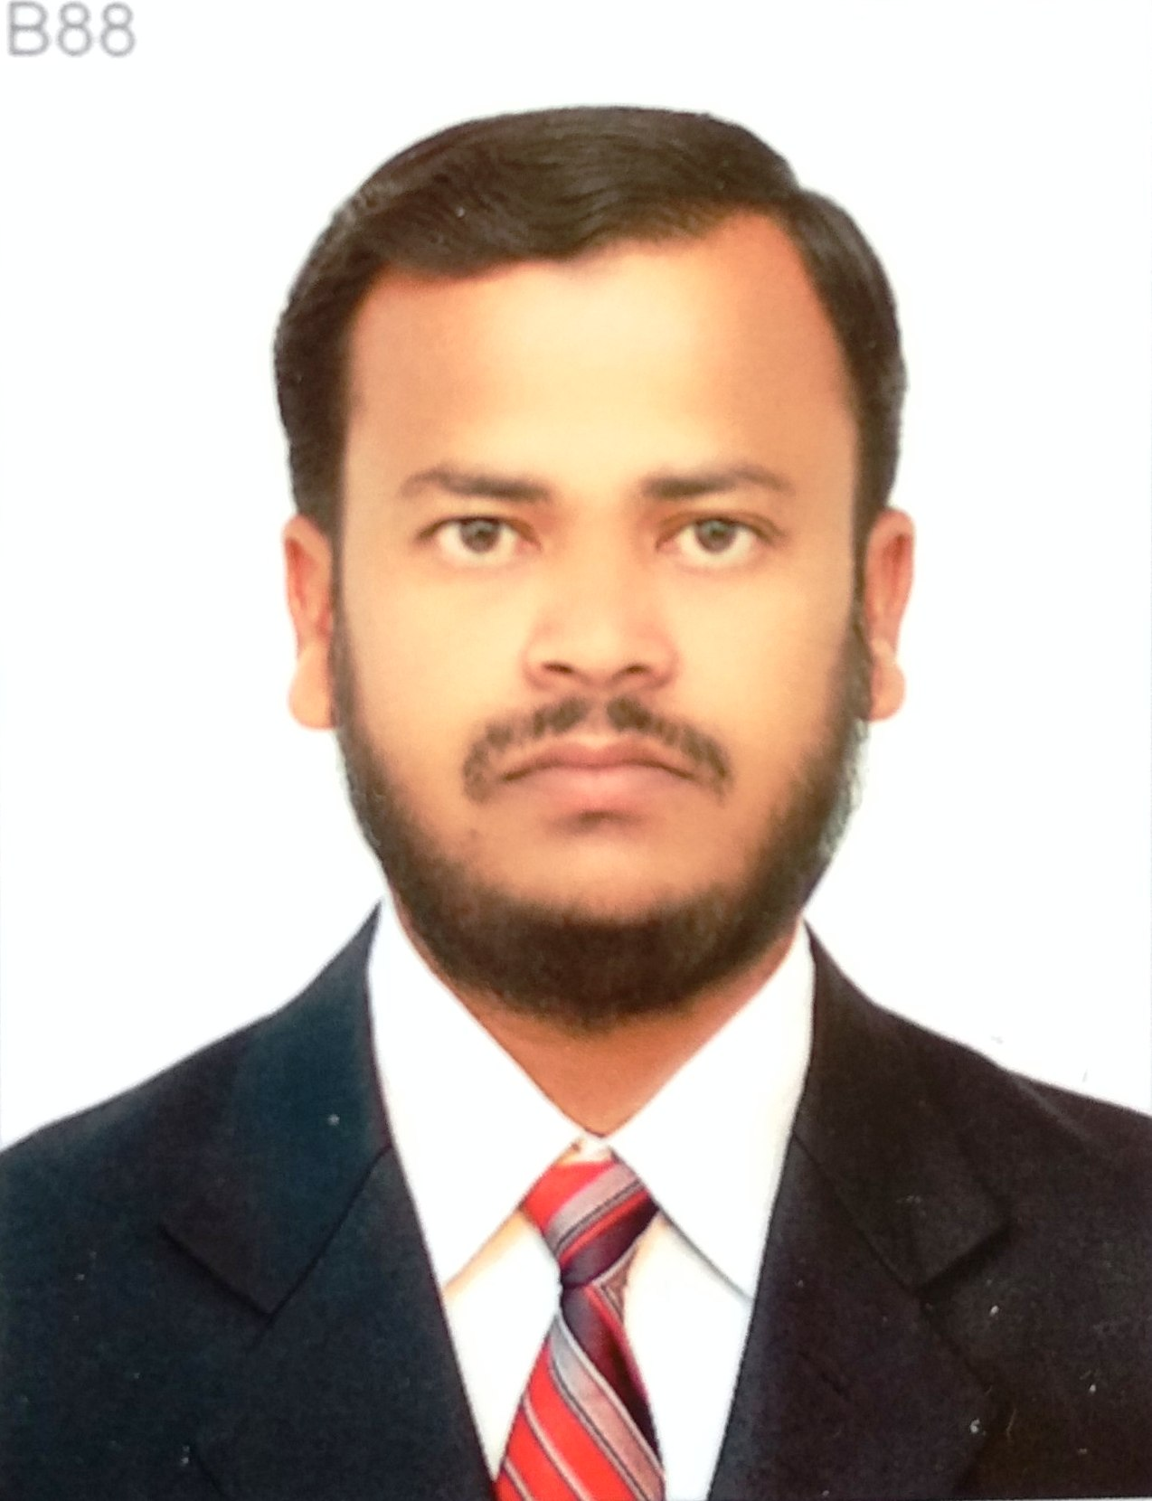
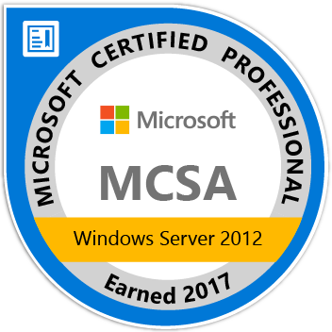

KHALEEM AHMED Mobile No: - +91-7975247113
+91-7829212138
Skype ID: - khaleem.ahmed1
Email: - gulbargacity712@gmail.com

Career Objective.

To acquire the competencies required for a successful career by working on challenging projects that offer equal potential to learn and grow by the spirit of teamwork.

Education Qualification.

- Diploma in Computer Science & Engineering. Govt. of Karnataka. Dept. Of Technical Education, from Govt. Polytechnic Gulbarga May – 2006.

- SSLC. Karnataka State Secondary Education Examination Board, from S.G.V Hindi School Shahabad March – 2003.

Professional Work Experience.

- Working in Prabuddha Mitra Education & Charitable Trust(R). as an "IT Trainer " from April 2020 to present.

- Worked in Sone India Star Electronics Pvt Ltd. as an “IT Technical Support” from July 2017 to February 2020.

- Worked in Tareg Al Jaafari Cont Est. as an “IT Engineer” at Dammam (Kingdom of Saudi Arabia) from December 2015 to January 2017.

- Worked in Abdul Rahman Al-Otaishan Group for Contracting. As a “Hardware & Networking Engineer” at Dammam (Kingdom of Saudi Arabia) from June 2011 to June 2014.

- Worked in New Horizon as a “Desktop Support Engineer” at Gulbarga, from October 2009 to February 2011.

- Worked in Bharat Earth Movers Ltd. as a “Technical Hardware & Networking Trainee” at Bangalore, from March 2008 to March 2009.

Certifications.

MICROSOFT CERTIFIED ID : MC ID: 14420187.
MCSA (Microsoft Certified Solution Associate) : Certification No: G075-7060.
MCP (Microsoft Certified Professional) : Certification No: G073-7081.

SAUDI ARAMCO ID : Contractor Card No: 8034005.

Computer Skills.

Operating System.
- Window 98,2000, 2008, XP, Windows 7, Windows 8,Windows 10, Windows 11.
- Linux (Ubuntu, RedHat, Fedorall, OpenSuse, LinuxMint, CentOS).

Microsoft Office Suites.
- Microsoft 2007/2010 (Excel, Word, Power Point, Access, Publisher, OneNote).

Computer Hardware Technical Skills.
- Computer assembling and Installation OS.
- Configuring BIOS and CMOS settings.
- Troubleshooting Hardware and Software problems.
- Installing and configuring the peripherals, components and drivers.
- Installing software and application to user standards.
- Installing and Configuring IDE and SCSI devices.
- Deep knowledge of printer and cartage refilling.
- Familiar with hardware tools like servers, printers, VoIP, networking and telecommunications devices.
- Excellent troubleshooting skills in complex software and hardware problems.
- Installed Hard Disks, Floppy Drives, CD/DVD Drives, Sound Blaster cards, CPU, Memory, Power supply unit, Network Card, Video graphics Card, Sound Card Hard disk controller card on PC systems.
- Troubleshooting of personal computers. On line Support to customers concerning their computer problems.
- Expertise hands in troubleshooting of Computer hardware related problems such like UPS, SMPS, Printer and Drivers.
- Configuring Backup and Data Recovery (System Restore, Migrating user profile data old system to new system).

Network Administrator Technical Skills.
- Responsible for supporting entire software network for this 400-employee company, including LAN technologies, internet, intranet, and Ethernet systems.
- Responsible for cross-connecting multi-plat former systems and providing website traffic strings for tech support communications.
- Ability to configure and maintain organizations internal computer network.
- Expert experience with troubleshooting computer hardware related problems.
- Experience managing network security tools.
- Experience managing firewalls, anti-virus and intrusion detection systems.
- Identifying network performance issues.
- Configuration of network equipment’s.
- Managing and maintenance of network equipment’s.
- Troubleshooting, solving and documenting network connectivity issues.
- Network processing, centralized and distributive network connection.
- Installing, configuring and administering network technologies.
- Configuring Router, Switches, Modem(ADSL), Wireless and Broadband services.
Windows Server Technical Skills.
- Windows Server 2008/2012R2/2016/2019 installation, configuring and troubleshooting.
- Installation and configuring servers DNS Server, Active Directory domain controller.
- Installation and configuring Dynamic Host Configuration Protocol (DHCP Server)
- Configuring group policy’s (GPO) for users and computers accounts.
- Installation and Configuring Windows Deployment services (WDS).
- Installation and Configuring Internet Information Services (IIS.7.0)
- Installation and Configuring Microsoft System Center and Configuration (SSCM)
- Installation and configuring File Transfer Protocol (FTP).
- Installation and configuring Printer and Document services.
- Microsoft Office365 Exchange server configuration new user, modifying user accounts, troubleshooting email issues (POP3 IMAP SMTP).
- Configuring and troubleshooting Microsoft Outlook, and Outlook express.
- Firewall installation and configuration.
- Basic knowledge of Hyper-V installation and configuring.
- VMware workstation 12 extensive knowledge of windows server 2008/2012 DNS, Active Directory, DHCP, WDS, IIS 7.0 FTP.

Passport Details.

Passport Number : S6259540
Date of Issue : 01/09/2018
Date of Expiry : 31/08/2028
Place of Issue : Bengaluru.

Personal Details.

Name : Khaleem Ahmed
Father Name : Mohammed Ibrahim
Date of Birth : 23 July 1987.
Sex : Male
Marital Status : Single
Nationality : Indian
Religion : Muslim
Languages Known : Hindi, English, Kannada, Urdu, and Arabic.
Permanent Address : Khaleem Ahmed
S/o Mohammed Ibrahim
Bharat Bakery Jama Masjid Chowk
PO: SHAHABAD-585228.
Dist: Kalaburgi (Gulbarga). State: - Karnataka.
Declaration:

The information presented is true to the best of my knowledge and I am looking forward for a successful career that helps in achieving my personal and professional development.

Date :
Place : KHALEEM AHMED

