To,

The H. R Manager, Recruitment Cell.

SUBJECT | : Application for the post of Quality Engineer/Mechanical Engineer in your company.

Sir/Madam,

I, SREENADH A S, have completed B.tech. in Mechanical Engineering possessing excellent Communication, Interpersonal skills and Good client co-ordination. I am fully confident and able to take projects from conceptualization through to implementation.

I hereby offer myself as an applicant in your reputed organization. My perception of your organization in particular has inspired me to offer myself as for the given designation .I would strive to serve your organization with the best of my capability. Though I am sending this covering letter for your attention, I request you to allow me to present my case in person. I write to you in this regard and seek your affirmative action at the earliest.

All references are available on request Thanking you.

Yours Sincerely, SREENADH A S
Attached: Résumé, Engineering Course certificate,NDT certificates,Experience certificates.

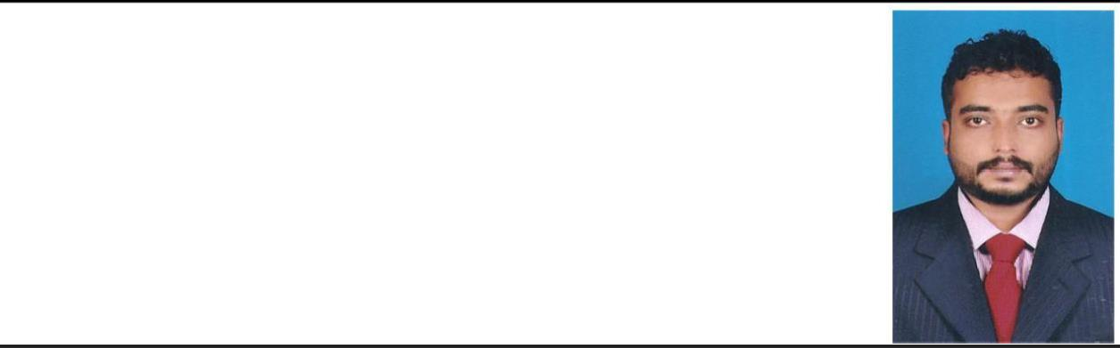SREENADH A S
KALARICKAL HOUSE
Elanji P.O Alapuram ERANAKULAM
Contact : Mob: +91 9567310793/+91 7025152403
Whatsapp no - +91 7025152403
Email : sreenadhas989@gmail.com

Objective : To utilize my knowledge towards a challenging career in a growth oriented, leading organization where professionalism and protection is respect and which will provide me with ample opportunities towards using my abilities and talents in the best way towards the organization’s
development.
Personal Appraisal : Hard working
Very good interpersonal skills Fast Learner & Self motivated Eligible for team work
Subordination to Almighty

Educational Qualifications:

COURSE | NAME OF INSTITUTION | BOARD/UNI | YEAR OF | PERCENTAGE
COURSE | NAME OF INSTITUTION | VERSITY | PASSING | OF MARKS
CLASS X | Technical Higher Secondary | THSSLC | 2004 | 69.9%
CLASS X | School,Muttom | THSSLC | 2004 | 69.9%
CLASS XII | Technical Higher Secondary | THSE | 2006 | 66%
CLASS XII | School,Muttom | THSE | 2006 | 66%
B-TECH | Mangalam college of | MAHATMA | 2010
(Mechanical ) | Engineering, Ettumanoor , | GANDHI | 2010 | COURSE
 | Kottayam | UNIVERSITY | 2010 | COMPLETED

COURSE | NAME OF INSTITUTION | BOARD/UNIVE | YEAR OF | PERCENTAGE
COURSE | NAME OF INSTITUTION | RSITY | PASSING | OF MARKS
PROCESS PIPING | ST.JOHNS INSTITUTE OF | ASME B – 31.3 | 2011 | FIRST GRADE
DESING & | PIPING ENGINEERING | ASME B – 31.3 | 2011 | FIRST GRADE
ENGINEERING |  | ASME B – 31.3 | 2011 | FIRST GRADE
RADIOGRAPHIC | ST.JOHNS INSTITUTE OF | ASNT | 2011 | 89
TESTING | PIPING ENGINEERING | ASNT | 2011 | 89
MAGNETIC PARTICLE | ST.JOHNS INSTITUTE OF | ASNT | 2011 | 90
TESTING | PIPING ENGINEERING | ASNT | 2011 | 90
LIQID PENETRANT | ST.JOHNS INSTITUTE OF | ASNT | 2011 | 91
TESTING | PIPING ENGINEERING | ASNT | 2011 | 91
ULTRASONIC TESTING | ST.JOHNS INSTITUTE OF | ASNT | 2011 | 89
ULTRASONIC TESTING | PIPING ENGINEERING | ASNT | 2011 | 89

Skills Set : C, C++, MICROSOFT WORD,MICROSOFT EXCEL,WINDOWS.

WORK EXPERIENCE:

➢

TOTAL EXPERIENCE: 10 YEARS

- EMPLOYER-PRAJ INDUSTRIES LIMITED (PUNE)
PROJECT-220 KLPD DISTILLERY / 107 TS
DESIGNATION – QA/QC ENGINEER
DURATION- SEPTEMBER 2020-PRESENT

EMPLOYER: ELECO
✓
PROJECT :KIPIC MINA AL ZOUR PROJECT DESIGNATION: QA/QC ENGINEER DURATION : JAN 2019 – MAY 2020
✓

EMPLOYER: SKYWAYS
PROJECT :DOHA POWER PLANT PROJECT DESIGNATION: QA/QC ENGINEER DURATION : JULY 2018 – DEC 2018
✓
EMPLOYER: A M KOYA ENGINEERING

PROJECT :CONSTRUCTION OF LESBAR (Tank & Piping) IN MYSORE
DESIGNATION: QA/QC ENGINEER DURATION : AUG 2017 - MAR 2018

✓
PROJECT : CONSTRUCTION OF LESBAR (Tank &Piping) IN TAMILNADU
NEWSPRINT LIMITED,TAMILNADU
DESIGNATION : QA/QC ENGINEER COMPANY A M KOYA ENGINEERING DURATION : OCT 2016 - MAY 2017

✓
PROJECT : FABRICATION AND ERECTION OF 17 MS TANKS & Associated Piping IN
KAKIRA DISTILLERY UGANDA
DESIGNATION : QA/QC ENGINEER COMPANY : A M KOYA ENGINEERING DURATION : JUL 2015 - JUL 2016

✓
PROJECT : FABRICATION AND ERECTION OF MS TANK IN CHENNAI PETROLEUM

CORPORATION LIMITED
DESIGNATION : QA/QC ENGINEER
COMPANY : AM KOYA ENGINEERING
DURATION : AUG 2013 - APR 2015

PROJECT : MECHANICAL PIPING IN CHENNAI PETROLEUM CORPORATION LIMITED

DESIGNATION : QA/QC ENGINEER COMPANY : GULF ENGINEERS PVT LTD DURATION : MAR 2012 - MAY 2013

✓
PROJECT : MECHANICAL PIPING IN CHENNAI PETROLEUM CORPORATION

LIMITED

DESIGNATION : QA/QC ENGINEER COMPANY : GOPAL ENGINEERING DURATION : AUG 2010 - FEB 2012

Personal Details :-
Name of Father | : | Suresh Kumar A S
Name of Mother | : | Vijayalakshmi J
Date of Birth | : | 09-01-1989
Age | : | 34
Nationality | : | Indian
Marital Status | : | Single
Driving License | : | Two wheeler, Four Wheeler.
Languages | : | English, Malayalam, Hindi and Tamil.

Declaration:

I hereby solemnly affirm that all the details furnished above are true to the best of my knowledge.

