Curriculum Vitae | 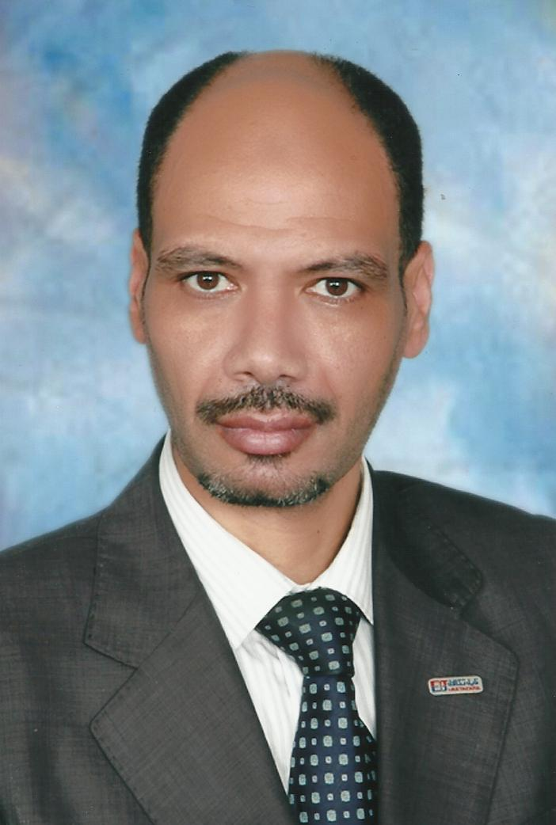
PERSONAL INFORMATION
First name(s) / Surname(s) | Ahmed Salem
Address(es) | 217, Mostafa Kamel St., Alexandria, Egypt
Telephone(s) | 0020 1011577574
E-mail | ahmed.salem769@gmail.com
Skype ID | Ahmed.kh69
Nationality | Egyptian
Date of birth | July 13, 1972
Gender | Male
DESIRED EMPLOYMENT | LEAD ENGINEER INSTRUMENT & CONTROL  ICSS
SUMMARY | 20 years + global experience in Oil & Gas facilities (Onshore/Offshore), Refinery & Petrochemical projects,Sub Sea. Utilities and other Process industries-Instrumentation Engineer with demonstrable experience in Commissioning EPC EPCI EPIC EPCM Feed Design PMC both Green & Brown field projects of detailed engineering;  - Engineering, Design and Project Execution for Instrumentation,Process Control Domain (PCD) DCS, PLC, SCADA, ESD and other Automation projects;  - Cost/Man-Hour Estimates and Feasibility studies of existing instrument and process;  - Specifications, Material Requisition Preparation, Procurement and analysis of vendor documents.;  - Selection, Sizing and Specifications of Field Instruments, MOVs, Control valves, Analyzers, Safety systems, PLC and DCS systems; -FOC Net Works  - Execution Experience with major DCS systems (like Honeywell, Yokogawa,Emerson , Delta V), PLC systems like (Allan Bradly Triconex, Honeywell ESD systems) and SCADA systems (like Semiens PCS7 etc.);  - HAZOP/SIL/ROOT CAUSE studies and Safety Analysis for process plants.
WORK EXPERIENCE
Dates | April, 2010 – Aug,2021
Occupation or position held | LEAD ENGINEER INSTRUMENT & CONTROL (ICSS)
Project | Member of CCC group (ADNOC)
employer | Sicon Oil & Gas S.P.A. – ITALY- UAE
Main activities and responsibilities | Major Projects Handled:  1) Abu Dhabi Gas Industries (ADNOC)-Train3 NGL Project,  2) Shell Houdini ECC Project, Associate  3) Saline Water Conversion Corpn â€“Power Plant & Desalination Project,  4) Schering Plough DCS upgradation Project,  5) Common Cooling Water Project ,Ras Laffan,Qatar (Qatar Petroleum Projects)  6) Terminal Automation Project for SHUAIBA AREA) Additional Product RESPONSIBILITIES AND DUTIES:  - Manages and provide direction in the execution of all electrical & instrumentation requirements of the assigned project in collaboration with Project Management Team; supervise the execution and installations along with the implementation of the Project Quality Standards that is responsive to the ISO requirements, policies, procedures and manuals as defined in the contractual agreement.  - Assess and carry out detail studies of the electrical scope of works, all instruments needed based on drawings and specifications, distribution of available resources and provide guidance to the entire electrical and instrumentation team in the performance of activities, in coordination with site QA/QC Inspectors.  - Work with the General Manager with the development of the Construction Execution Plan, controls of project cost and electrical & instrumentation schedule, and ensure participation with the Functional Team to align their functional plans and deliverables based on the project schedule to ensure objectives are accomplished within the prescribed time frame and budget parameters .  - Develops an understanding of all electrical & instrumentation aspects of the contract including controls change/scope creep, ensuring that all scope changes are quickly arid properly documented, and that change orders are approved prior to the performance of the work.  - Ensure permits to execute electrical & instrumentation tasks at job sites are completed daily and set the targets to complete on schedule. Liaise with the client's representatives to ensure proper and timely involvement and approval of electrical & instrumentation deliverables, as well as a professional and business-like client/contractor relationship throughout the life of the project.  - Provide guidance to the entire electrical & instrumentation team to perform various activities according to the IFC drawing, carry out installation of various activities (e.g., instrument junction box installation, analog & field foundation bus, control room, rack room and operator console interconnection cable installation and connections) according to the wiring diagram provided for construction.  - Coordinate with client regarding any technical clarification required for construction or any discrepancies in IFC drawings, prepare organization chart for the electrical & instrumentation team, prepare manpower histogram, monitors the deviation in work activities to include study of the process system and data sheets.  - Prepares monthly status reports for the project to keep the client and management informed of electrical & instrumentation construction progress and the status of costs and schedule as related to the budgets and previous forecasts.  - Implements, manages and maintains an effective working relations with the work groups to ensure that work proceeds without disruption, and maintaining daily communications to ensure the accurate and timely flow of information.  - Advises General Manager regarding developments that could affect project schedule, costs, client relations and or inter-departmentalrelations.
Dates | January, 2008 – March, 2010
Occupation or position held | Lead Engineer – Instrumentation- Control (OFF SHORE)
Project | Detail design project – Hydrogen Gas Plant Hydrogen Make-up Compressor for Kuwait National Petroleum Ltd. (KNPC- Mina Abdulla Refinery1000 I/O’s, Brownfield) – AHMADY OFF SHORE PLANT
Name and address of employer | Arebi Enertech – KUWAIT
Main activities and responsibilities | - provide technical assistance at an early stage of engineering phase, project execution and commissioning phase of hydrogen make up compressor;  - participate in design review, HAZOP, technical review meetings;  - involve during construction, engineering, equipment selection process, calculation process and electrical & instrument issues;  - preparation of instrument design basis, control & automation philosophy, control system overview diagram, specifications (field instruments, control valves, MOV & PSV'S) for hydrogen make-up compressor;  - review Yokogawa (CENTUM CS 3000 R3 – Emerson and DLTA V) design documents - function design specifications for DCS/ESD, GA drawing, system & marshalling cabinet drawing, power calculation, interlock logic diagrams FAT procedure and closed out FAT punch list items;  - prepare mapping lists for DCS-ESD, DCS-MMS and ESD-MMS system;  - prepare RFQ'S, datasheets, instrument index, wiring diagram, loop diagram, hook up diagram, cable schedule, bulk MTO and cause & effect diagram.  - prepared alarm list based on the criticality and priority of operational requirements (trip, high/low priority, common alarm);  - prepare technical reports for project management meetings, cost estimates and input to monthly budget submissions;  - involved in commercial negotiations with local instrument vendors and compressor package vendor;  - carry out the following function relative to vendor documentation;  - issue material requisitions (MPR) for material department for enquiry and order placement;  - liaise with project groups in relation to inst. & control associated with packages to ensure compliance with project standards & requirements;  - coordinating with project engineer in matters of project coordination & program, plant safety & work scope that could constitute a contract change;  - construction engineering of preparation of fabrication of support drawings/ routing and layout drawing;  - effective interface with suppliers and vendors to perform factory acceptance test [FAT], review and coordinate their day to day work at their factory works for technical issues;  - evaluation of vendor's quotation, prepare technical bid evaluation (TBE), commercial quotation evaluations;  - witnessed the functional checks before transfer the instrument item shipments to site for transmitters, control valves, MOV’s, Gauges, Switches, JB, instrument Cables etc;  - to carryout technical discussion and Factory Acceptance Test (FAT) for Honeywell DCS/ ESD system at Netherlands.
Dates | January, 2003 – December, 2007
Occupation or position held | Senior Engineer – Instrumentation-control
Project | SAUDI ARAMCO KHURAIS PROJECT KFJ- OFF SHORE  (ARAMCO KUWAIT OIL &GAS)- off shore
Name and address of employer | HYUNDAI ENGINERING COMPANY – KINGDOM OF SAUDI ARABIA
Main activities and responsibilities | - to direct engineering design team in development projects throughout the entire cycle from initial concept through successful completion.  - to finish assigned engineering projects in accordance with customer specifications and within schedule and budget limitations, coordinating activities of engineering team, contractors, and vendors. Role includes analysis, design, specification, selection, implementation, commissioning, cutover and start-up for Instrumentation, plant automation and process control systems. Discipline Lead role on project team providing analysis and design of instrumentation and control systems. Responsible for developing design basis documents, technical studies and reports. Being involved in the preparation of bid specifications, and evaluations.  - responsible for the development and design of control systems hardware & software architecture along with specifications & operating guidelines.  - other responsibilities include the participation in safety reviews, hazard analysis and coordination of engineering and design activities with other project disciplines.  - Detail Experience:  - Expertise in Proposals, Design, Development, Implementation and Execution of Project.  - Performs technical planning, system integration, verification & validation analysis & FAT.,SAT  - Ability to develops and integrates ESD, PSD, PLC, DCS and SCADA.  - All aspects of control system project engineering such as drawing developments and evaluation and application of project specification from conceptual design thro’validation.  - perform Basic Engineering by Understanding Process and Control parameters with Piping & Instrumentation Diagram (P & ID) with control philosophy FSD & HAZOP, SIL 2.  - design developing Instrumentation Specification sheets, preparing of Instrument Index sheets, loop Wiring details, Installation Details with Hook-up diagram, Cable Schedule, Junction Box details, Detailed Bill of Materials, Bid Evaluation:  interlock systems/Cause and Effect diagram.  - Control Valve, Orifice and Transmitter sizing Calculations. Particular about Material;  project planning, estimation and implementation;  risk analysis and HAZOP study and SIL2. SAFE charts and Cause and Effect analysis;  maintaining GPM level, ISO requirements, Instrumentation standards, ISA and IEC standards, API, IEC, ADCO AND SHELL STANDARD, SAUDI ARAMCO standards & MARAFIQ STANDARDS and developing policies & procedures, trouble shooting and debugging of software and hardware;  worked with ISO 9001, 2000, ISO 14001 and ISO 18001 certifiedcompany, SiemensS7-300 -S7-400PLC programming/coding along with connectivity of systems using Ethernet, Profibus, Modbus and their application within process plant design and engineering.
Dates | January, 2000 - December, 2002
Occupation or position held | Instrumentation Construction Supervisor
Project | Revamping and Maintenance Project for Kuwait National Petroleum Ltd. (Shuaiba Refinery Base design: Foster wheeler, UK, Brownfield
Name and address of employer | Kharafi National - KUWAIT
Main activities and responsibilities | - involved in Modernization of control room - Installation, Commissioning, start up and on line change over the control room instruments and DCS/ESD system.  - re-vamping operations – replacement of pneumatic instruments to new electronic instruments for Unifier, H2s plant, Gas treating area, Heavy oil and Utility area.  - carried out on line release up gradation of the old pneumatic System in to Honeywell TPS system.  - commissioning of Honeywell - TPS System configuration to new version i.e. GUS and High Performance Manager (HPM).  - replace the existing hardware and install the new hardware’s for the control room equipments.  - programming of Digital Controllers (Yokogawa).& SIEMENS  PCS 7-300 & PCSS7-400  - core team member of Alarm Management Group for complete Shuaiba Refinery and pumping area.  - carried out complete logic study, undertaken implementation check, installation and maintenance of Air Compressor (Cooper Beesmer, AC, AEG etc.) with lube oil and seal oil system, pumps and turbine.  - to plan and execute call out duty, shift duty, shutdown, start up activities.
Dates | October, 1996 – December, 1999
Occupation or position held | Engineer - Instrumentation
Project | Project Engineer (Instrumentation)
Name and address of employer | SUEZ Petrochemical Company - EGYPT
Main activities and responsibilities | The job involves up gradation of existing Honeywell MC to HPM, Industrial control (ICS) Fail safe system to Honeywell FSC and Bentley Nevada 3300 series vibration monitoring system for refinery Vacuum and Coker units.  - Preparation of Basic Engineering and Detail Engineering package for Distributed Control System(Honeywell TDC-3000), Emergency shutdown system(Honeywell FSC ) with M/s Honeywell  Engineer for preparing Functional Design Specification and Detail Design Specification for various system like MMS, HPM, FSC;  - Reviewing of specification sheets,Cause and effect charts,Interlock Diagrams,Logic Description sheets, Termination Schedule, Cable Schedule, Instrument index, Instrument hookup drawings, Instrument loop drawings, System Architecture drawings, Power Distribtion and Panel Drawings;  - Preparation of Functional Logic Diagram(FLD) and Ladder programming for Honeywell FSC-QMR, AB-PLC in refinery units;  - Involved in subsequent erection of system at site and commissioning of both DCS and ESD with all networking capabilities and maintenance of the same. Also involved in process loop checking and control algorithm checking,Logic checking after installation.  - Involved in HAZOP study of various refinery units and implementing the same;  - Involved in Machine Monitoring system Technical specification .
EDUCATION AND TRAINING
Dates | 1992-1996
Title of qualification awarded | Bachelor’s degree in Electrial (Electronics and Communications)
Name and type of organisation providing education and training | Faculty of Engineering - Alexandria University – Egypt (passed with first class)
STANDARDS KNOWN | ANSI, ISA, KNPC, PDO, API 617/ 618, Australian
Training/Special Assignments | - Project Management Professionals by PMI Jubail, KSA  - Triconex TMR ESD System, Jubail, KSA  - SAP System, Financial and Eng Project Management (PS Module) Jubail  - SAP System, Investment Management (IM Module) - KSA  - SAP System, Materials Management (MM Module) - KSA  - Yokogawa Centum CS3000 DCS system, Jubail, KSA  - Application Software FAT at Oxy-Vinyl, Jubail, Saudi Arabia  - Engineering and design review at Mustang Jubail, KSA  - Engineering and Design review at KTI, Zotermeer, the Netherlands  - Bosiet Certificat from INASEA Academy –GERMANY  Valid up to 06/2018
PERSONAL SKILLS AND COMPETENCES
Mother tongue(s) | Arabic
Other language(s) | English, French
Self-assessment
European level (*)
English  French | (*)Common European Framework of Reference for Languages
  Understanding |  |  |  | Speaking |  |  |  | Writing
  Listening |  | Reading |  | Spoken interaction |  | Spoken production
  C2 |  | C2 |  | C2 |  | C2 |  | C1
  B2 |  | B2 |  | A1 |  | A2 |  | A2
Social skills and competences | Comunicative person, optimist person, adaptable & flexible to change
Organisational skills and competences | Leader, good organizer, experience working in/with a team
Computer skills and competences | - SOFTWARE:  - Ladder Logic, Structure text, Function blocks, MS office, MS Project.  - HMI software, Wonder ware, I Design, ORICAL, FLOWCAL, CV.  - SIZING, Safety Valve Sizing, SAP, BaanN-5 , INST. Tools  - Instrumentation sizing software:  - AutoCAD/Micro station/PDMS/PDS/ Proprietary Control Soft wares (ICSS, SCADA, DCS, PLC, OPC server etc.)
Experience with instruments | - DCS: “APACS “Moore Controls. FOXBORO, YOKOGAWA, (CENTUM CS 3000 R3) - Honeywell –SIEMENS S7-300 " SIEMENS S7-400 HE &SW detailing and I/O listing.  - Cabinet and remote module PLC, SCADA: Allan Bradley, Mitsubishi, Messung, Siemens, Moore, Yokogawa , ABB, Telemechanique.  - Single Loop Controller: Yamatake Honeywell, Yokogawa, Moore, Fuji, Masibus.  - Transmitters: Fisher Rosemount, Honeywell, Yokogawa, E & H, Krohne Marshall.  - Final control Elements and MOV’s:-:BIFI, Valveitalia, BTG-CCI, FISHER, CVS, Arca, Dembla, Samson, Honeywell, El-omatic, Rotex.  - Temperature sensors , Flow sensors- Variable area flow meters, Mass flow meter, Mag flow meters, Vortex flow meter, Ultrasonic flow meters, Orifice and D/P Trans. Level measuring Instruments , Pressure Measuring instruments, Analytical instruments like pH meter, DO meter;  - Various Type of Gas detecting systems: General Monitor, MSA, ABB, UPL, Pentax, Fisher-Xomox, Servomax, Variable Frequency Drives and Vibration Monitoring.
Driving licence | Full current driving license (Saudi Arabia)

