CURRICULUM VITAE

Name as in Passport: | MOHAMED SHEFEER | 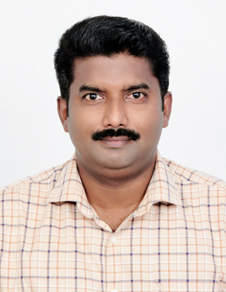
Address: | SHIFA PUTHIYAVEETTIL,  KATTAYAN STREET,  PUDUNAGARAM.P. O,  PALAKKAD-DISTRICT,  PIN:678503
Contact Number: | +919446713369, +919746601511.
Email: | shefeershaji@gmail.com, shefeer575@gmail.com
Educational Qualifications
SL NO | TITLE OF QUALIFICATION | NAME OF QUALIFICATION | NAME & PLACE OF UNIVERSITY/BOARD | YEAR OF PASSING
1 | SSLC | SSLC PASSED | GOV.T HIGH SCHOOL, PATTENCHERY,  KERALA BOARD OF PUBLIC EXAMINATION. | 1991
2 | COMPUTER EDUCATION | D BASE 3+, LOTUS 1-2-3 | J.K. INSTITUTE FOR COMPUTER STUDIES | 1992

Employment/Work Experience
SL NO | DURATION OF EMPLOYMENT |  | NAME & PLACE OF ORGANIZATION | DESIGNATION
SL NO | FROM  (DD/MM/YYYY) | TO  (DD/MM/YYYY) | NAME & PLACE OF ORGANIZATION | DESIGNATION
1 | 01/08/2000 | 25/05/2012 | EPPCO-DUBAI | ASSISTANT TESTER
2 | 01/08/2012 | 13/09/2014 | PAUL ALUKKAS JEWELLERY | DRIVER
3 | 07/06/2016 | 10/04/2021 | MYZECK ENTERPRISES | SALESMAN, CASHIER

Personal details
Passport Number: |  | V2824152
Date of birth: |  | 25/05/1975 |  | Gender: |  | MALE
Marital status : |  | MARRIED |  | Religion: |  | ISLAM
License details
License No: | 45/8421/1993 |  | Date of Issue: |  | 20/11/1993
Class of Vehicles: | M/C,LIGHT and HEAVY |  | Badge no: |  | 9/2184/2012
GCC License: | DUBAI EXPIRED

Declaration
I hereby declare that the information given in this document is true and correct.
DATE: 02/02/2021 NAME: MOHAMED SHEFEER

